Infectious Disease Simulation Project

**Compilation and Running Instructions:**

**Exercise 39.1:**

**Compile:** $ icpc –std=c++11 39.1_main.cc Population.cc Person.cc -o ex391

**Run:** $ ./ex391

**Exercise 39.2:**

**Compile:** $ icpc –std=c++11 39.2_main.cc Population.cc Person.cc -o ex392

**Run:** $ ./ex392

**Exercise 39.3:**

**Compile:** $ icpc –std=c++11 39.3_main.cc Population.cc Person.cc -o ex393

**Run:** $ ./ex393

**Exercise 39.4:**

**Compile:** $ icpc –std=c++11 39.4_main.cc Population.cc Person.cc -o ex394

**Run:** $ ./ex394

**Exercise 39.5:**

**Compile:** $ icpc –std=c++11 diseasesim_main.cc Population.cc Person.cc -o diseasesim

**Run:** $ ./diseasesim

**Variable Summary:**

popn… Number of people in the population

mypop… The population being tested

inocn… Number of people inoculated

inocrate… Current inoculation rate

infrate… Current infection rate

(Method descriptions in respective header files)

**Description:**

The main program I used for data analysis, “diseasesim_main.cc,” asks the user to input the population size for the simulation. It then runs through three for-loops; the first loop increases the inoculation rate by 0.01 from 0 to 0.99, the second loop increases the infection rate by 0.01 from 0 to 0.99, and the last for loop runs the simulation ten times at each inoculation and infection rate combination. The number of iterations (or days) that the disease survived, and the fraction of susceptible people who escaped infection for each combination is recorded for each simulation. The values are then averaged together for the 10 simulations and written to a .csv file for graphical analysis.

The model that we have used for this project is the SIR model. It is a very simple infectious disease model, with the letters in the name standing for the different states a subject can be in: “S” is for susceptible, “I” is for the infectious, and “R” is for the recovered (immune). The status trait of the person class represents these different states of the subject. A status value of -2 means the subject has been vaccinated and cannot be infected, a value of -1 means the subject has recovered from the disease and cannot be infected again, a value of 0 means the subject is susceptible, and a value greater than zero shows how many more days the subject is infectious for. The model is given an infection rate to define how easily the disease spreads, and an inoculation rate to define how many people in the population are initially vaccinated. When the subjects are infected, they are infectious for 6 days and interact with 6 random people each iteration in the simulation. After the 6 days, the subject recovers and can no longer infect others or be infected.

**Results:**

**Exercise 39.1:**

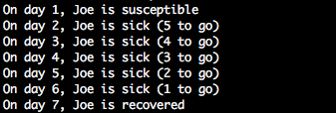

**Exercise 39.2:**

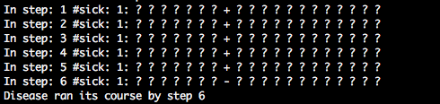

**Exercise 39.3:**

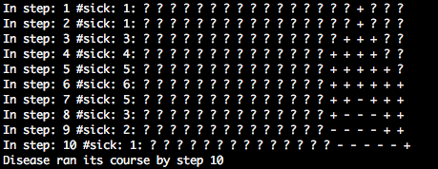

**Exercise 39.4:**

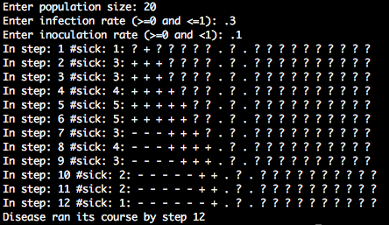

**Exercise 39.5:**

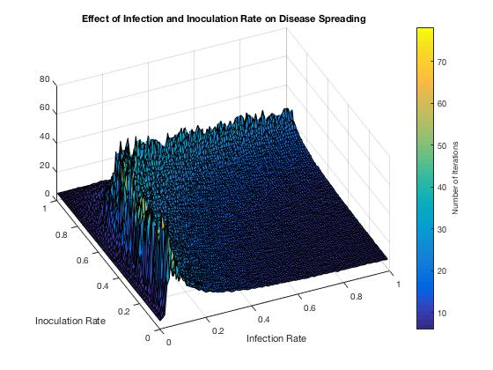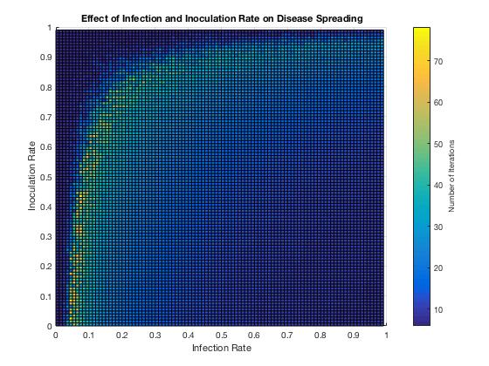

**Fig. 1:** The graph displays the effects of different inoculation and infection rate values on the number of iterations the disease survived for.

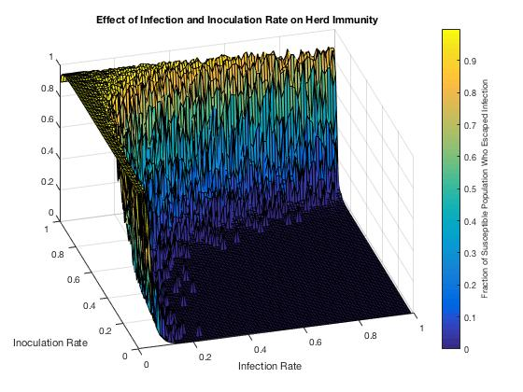

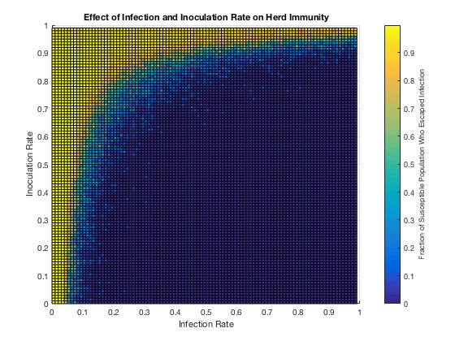

**Fig. 2:** The graph displays the effects of inoculation and infection rates on the number of susceptible (not inoculated) people who were not infected by the disease by the time is ran its course.

**Discussion:**

**Exercise 39.1:**

The output of this exercise makes sense. The infection rate for the program was set to 95%, so joe was infected early and the disease ran its course after 5 days.

**Exercise 39.2:**

In this exercise, only one person is infected, and the disease does not spread to anyone else in the population. Therefore, only one person is infected and the disease dissipates after 6 days.

**Exercise 39.3:**

There are many cases where people escape getting sick. From the sample output provided, you can see that the disease reaches the end of the population vector on the right side, and is not able to spread further in that direction. Also, the infection rate is not high enough to keep spreading through the subjects on the left. Higher infection rates greater than 0.5 usually were able to spread to the entire population.

**Exercise 39.4:**

This model is unrealistic. Only the people to each side of an infected individual are being exposed to the disease. So, if the people next to the infected person are inoculated, or there isn’t a person on one side, then the disease stops spreading. In the sample output, the infected individuals were bordered by inoculated people on the right side and reached the end of the population on the left side, stopping it from spreading to anyone else. A much more realistic model would include random interactions and infections with different people throughout the population.

**Exercise 39.5:**

The data on the graphs was conducted on a population size of 1000, but increasing the population size only increased the range for the number of iterations and did not change the results. For the two graphs, the x-axis represents the probability of transferring the disease to another subject on contact, and the y-axis represents what percentage of the population that was initially inoculated (or vaccinated). For both of these axes, the values range from 0 (0%) to .99 (99%). For Fig. 1, the z-axis represents the number of iterations (or days) that the disease survived for. For Fig. 2, the z-axis represents the number of susceptible people who escaped being infected by the disease.

As you can see from the Fig. 1, the infection rate and the inoculation rate have a logarithmic relationship with respect to the number of iterations the disease survived. The number of iterations increases quickly until it reaches some optimum infection rate for each inoculation rate, and then slowly decreases after passing this optimum threshold. If the infection rate is too high, the disease spreads rapidly through the through the population, and the population develops mass immunity and the disease dissipates quickly as the population recovers. However, if the infection rate is too low, the disease does not spread fast enough, and the subjects recover before it can be transmitted to another person. The optimum inoculation and infection rate pair follow a logarithmic curve.

The effects of ‘herd immunity’ for high inoculation rates can be seen in Fig. 2. There are generally two cases where the percentage of people who were susceptible but didn’t get sick was above 95%: very high inoculation rates, or very low infection rates. For very high inoculation rates, the disease does not have enough people to spread to, so the subjects recover before the disease can be transferred to the next person, and many unvaccinated people escape infection. For very low infection rates, the disease is not infectious enough to spread to other people in the population before the subjects recover. In these cases, the disease usually only lasts for about six iterations. As you can see, Fig.1 and Fig. 2 line up quite nicely. The cases with a low number of iterations generally have a very high percentage (>95%) of susceptible people escaping infection, which makes sense. However, the cases with the largest number of iterations also have a portion of the population escape infection (around 50%). The optimum infection and inoculation curve from Fig. 1 lines up with the curve in Fig. 2. This shows that the disease doesn’t necessarily need to infect every single person in the population in order to survive the longest. Instead the optimal conditions for the disease to survive at a certain infection and inoculation rate are a balance between infecting enough people at a fast-enough rate, while also not infecting people too quickly and allowing the population to develop mass immunity early on in the simulation. A higher inoculation rate helps to keep this balance for higher infection rates by not allowing the disease to move through the population too quickly. At very low infection rates, between 0.05 and 0.1, the infection slowly creeps through the population, dragging out its time of survival, and the inoculation rate does not become a huge factor until a value of about 0.6.